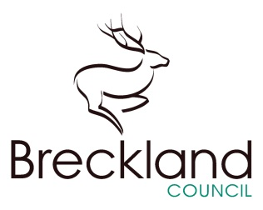

**Breckland Council**

Elizabeth House

Walpole Loke

Dereham

Norfolk

NR19 1EE

Date: 27/06/18

Our reference: BFOI-005443

Your reference:

**Parsons**

Dear Mr Parsons

**BDC FOI RE - FOI Administration Info Ref: BFOI-005443**

Breckland District Council acknowledges receipt of your request for information received on 27 June 2018.

Your request is being considered and you will receive the information requested within the statutory timescale of 20 working days (25 July 2018) as defined by the Freedom of Information Act 2000, subject to the information not being exempt or containing a reference to a third party.

If appropriate, the information may be provided in paper copy, normal font size. If you require alternative formats, e.g. language, audio, large print, etc. then please let me know.

For your information, the Act defines a number of exemptions which may prevent release of the information you have requested. There will be an assessment and if any of the exemption categories apply then the information will not be released. You will be informed if this is the case, including your rights of appeal.

If the information you request contains reference to a third party then they may be consulted prior to a decision being taken on whether or not to release the information to you. You will be informed if this is the case.

There may a fee payable for this information. This will be considered and you will be informed if a fee is payable. In this event the fee must be paid before the information is processed and released. The 20 working day time limit for responses is suspended until receipt of the payment.

If you have any queries or concerns then please contact us at:

Freedom of Information Team

Breckland District Council

Elizabeth House

Walpole Loke

Dereham

NR19 1EE

[freedomofinformation@breckland.gov.uk](mailto:freedomofinformation@breckland.gov.uk)

Further information is also available from the Information Commissioner at:

Information Commissioner's Office

Wycliffe House

Water Lane

Wilmslow

Cheshire

SK9 5AF

The link below will refer you to the ICO website, which may be of use:

[www.ico.org.uk](http://www.ico.org.uk)

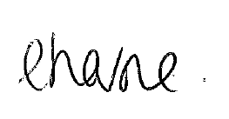Yours sincerely

**Elley Horne**

**Statutory Information Officer**

**Breckland District Council**

**01362 656 870**